
Shenandoah Valley Governor’s School

49 Hornet Road Fishersville, VA 22939 (540) 245-5088 www.svgs.k12.va.us

July 15th, 2022
Dear Students and Parents,
We hope everyone is enjoying some time off this summer! We are excited to welcome you to SVGS for the 2022-2023 school year. Your student has worked hard for this opportunity and has been selected to become a valued part of a unique educational environment. Our programs and courses are designed to challenge highly motivated students in the Arts and Sciences. Students are asked to demonstrate their abilities and talents in different ways and to become effective independent learners and thinkers.

We work to help our students understand and appreciate their ability to positively affect the world as the leaders, thinkers and creators of the next generation. We appreciate students’ accomplishments as evidence of what they have done, but challenge them to gain new skills and to understand their potential for what they can and will accomplish in the future.

As you know, all NEW students will attend a mandatory orientation August 8th. The first day of classes for ALL students is August 9th. There is also information on the next page on how to sign up for one of our “Photos and Forms” sessions for new students. Many of you have already done this! During that time, students will learn what they can expect as a student at SVGS and how to be successful in a different learning environment. Students will meet their peers from other schools, returning students and teachers. They will learn to navigate SVGS and use our technology. Orientation activities focus on understanding the academic expectations in their program. Students will participate in various projects/labs, other class activities, have their first assignments and attend a regular day of classes. Activities are designed to help students transition successfully to both a new school and new challenges. Students are responsible for their own transportation on August 9. Lunch will be provided that day as well.
Attached is basic information regarding the orientation schedule, other important information and events, classes, and tuition/fees. Please visit our website http://www.svgs.k12.va.us for additional information prior to orientation week and throughout the year. There are also tutorials for parents regarding: Infinite Campus Portals for student/parent, how to set up a Microsoft account, and how to log into the SVGS CANVAS LMS. New SVGS parents will be emailed a code to log into Infinite Campus. I encourage you to check our website regularly and also follow us on Facebook or Twitter to keep up with SVGS events, important information and the work of our students.

Please do not hesitate to contact me if you have questions. Best wishes for a wonderful summer and a great year!

Sincerely,
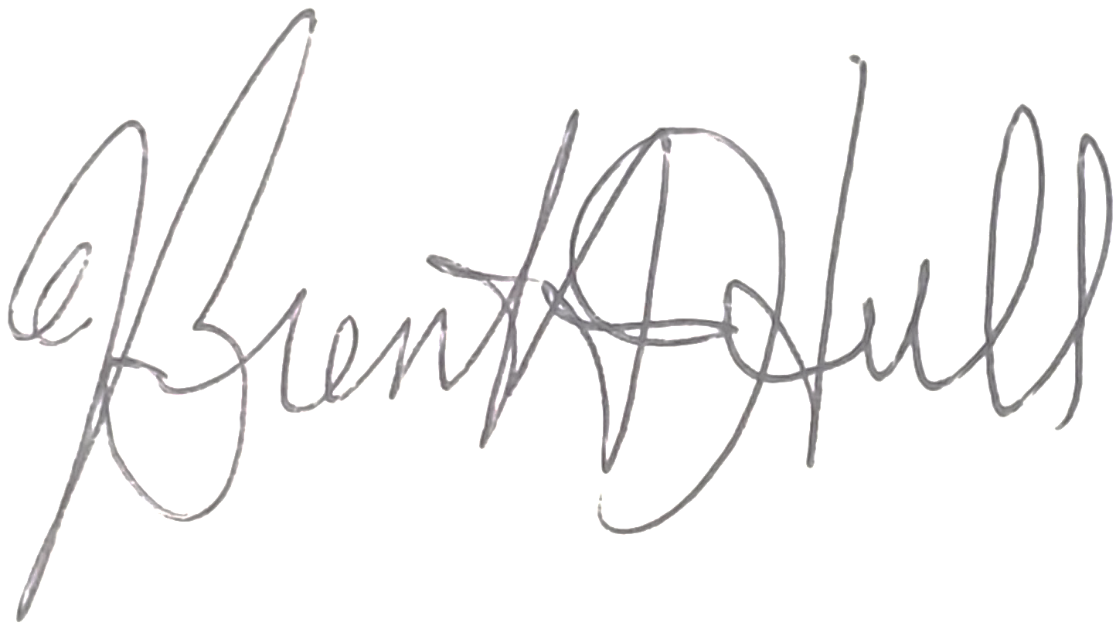
Brent A. Hull, M.Ed.
Coordinator
Shenandoah Valley Governor’s School

Shenandoah Valley Governor’s School

49 Hornet Road Fishersville, VA 22939 (540) 245-5088 www.svgs.k12.va.us

TO: SVGS New Students and Parents
FROM: Brent A. Hull
DATE: July 15, 2022
SUBJECT: Information for Orientation, Pre- School Workshops for New Students, Forms, Courses and Tuition Invoice

Welcome to SVGS! We look forward to working with you this year. Below is important information to help you get started. References and links can also be located on our school website http://www.svgs.k12.va.us. Please contact me at 245-5088 or hullb@svgs.k12.va.us if you have questions.

ORIENTATION and BACK TO SCHOOL DATES
Students are asked to sign up for one “Photos and Forms” workshop prior to our new student orientation on August 8. The link to sign up is posted on our website, or students can use: SVGS: Tech, Photos, and Forms Session (signupgenius.com) Dates and times for SVGS new student orientation, important events, and Back to School night are as follows:
Tuesday, July 26  Thursday, July 28 | Photos and Forms Day 1  Photos and Forms Day 2 | 8:00 a.m. -12:00 p.m.  8:00 a.m. -12:00 p.m.
Wednesday, August 3  Thursday, August 4  Monday, August 8  Tuesday, August 9  Thursday, August 11th | Photos and Forms Day 3  Photos and Forms Day 4  Orientation for ALL NEW students  1st day of school for ALL SVGS students  “Back to School” Night for all students, parents and staff  Tuition/ Fees, and any late forms for First Semester Due (unless other arrangements have been made prior) | 8:00 a.m. -12:00 p.m.  8:00 a.m. -12:00 p.m.  8:00 a.m. – 12:00 p.m.  7:38-10:52.  6:00-7:30 p.m.
* Orientation is mandatory for all new students.
** All students will begin classes on Tuesday, August 9th.
STUDENT FORMS
Emergency care cards and other student forms are available on our website under the homepage or the main menu item “Parents”. Please see the school’s website to access student forms. They may be completed and signed electronically or they may be downloaded, signed and returned. Copies are also available at SVGS.

Each form must be completed electronically or a signed copy returned to Sherri Robords, SVGS Secretary, by
Thursday, August 11.

COURSE REQUESTS AND TUITION INVOICE
Enclosed are your course selections and invoice for tuition and fees for the 2022-23 school year.
-Please check the invoice to be sure the classes listed are correct and contact me immediately if there is a mistake/change. There will be no schedule changes after July 28th.
-Tuition and fees for first semester (or half of the balance) are due August 12.
PAYMENT INFORMATION
- Please make checks payable to SVGS. If a payment plan OR financial assistance is needed, please contact Brent Hull, Principal/Coordinator, hullb@svgs.k12.va.us or 245-5088 as soon as possible. Please check website for more information regarding assistance for students in financial need and how the PSAC can help.

